Name: Timothy Ng Tik Ti  
ID: P7362270

Name and purpose of the chatbot

The bot is called TikyInsureBot. It’s objective is to find out what kind of insurance does the user want, and collect personal information needed to plan for them.

Intents/follow-up/default welcome intents used

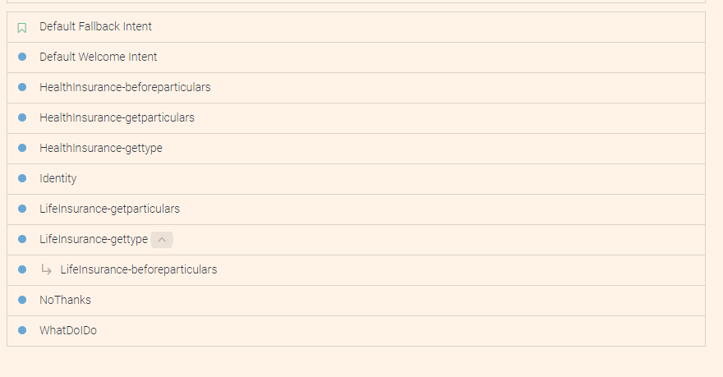

The above shows the intent that’s being utilized. At the start user will be greeted by the welcome intent, and when asked ‘who are you’ the *Identity* intent will give a short introduction. Next should the user ask for help, or ask ‘what do you do?’, the *WhatDoIDo* intent is activated and in short it is to ask user if they require life or health insurance more.

Subsequently, depending on which they choose, *HealthInsurance-gettype* or *LifeInsurance-gettype* will ask them which aspect of life or health insurance that they want more emphasis on. With the information, the bot then asks user to for their particulars through *beforeparticulars* and *getparticulars* intent sequentially.

An example of the conversation flow is below, with demonstration for the rich message and integration with Telegram:

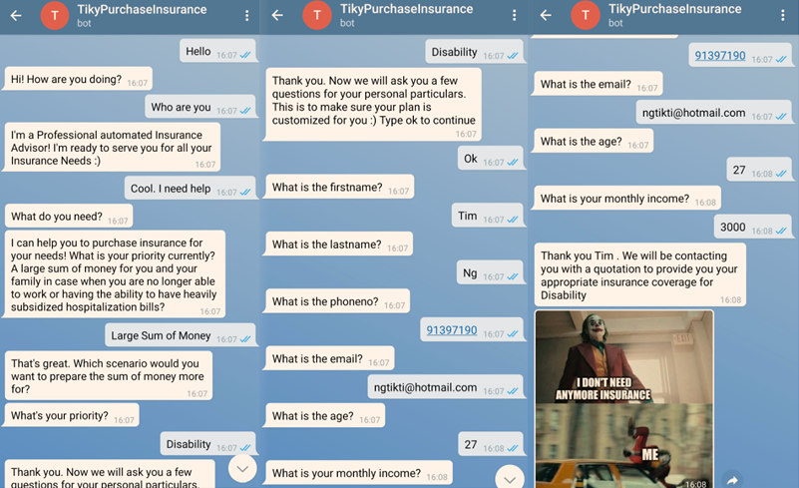

Entities and parameters

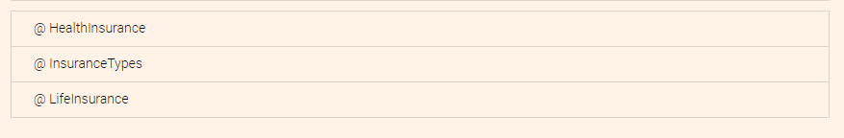

These were the entities. They are used to classify the different types of insurances. Here is an example of the entities for Health Insurance

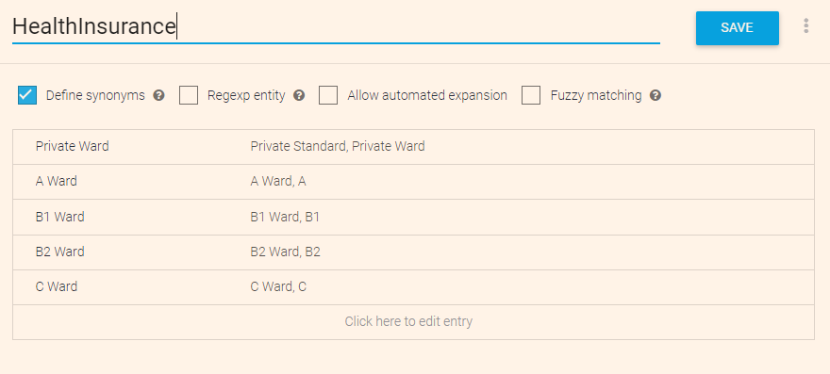

How input and output contexts were utilized

The input and output contexts were utilized to identify which type of insurance and which aspect or category of the insurance that the user is going for. For example, under the getparticulars intent, it’s being used to acknowledge which aspect of insurance that user is trying to prioritize.

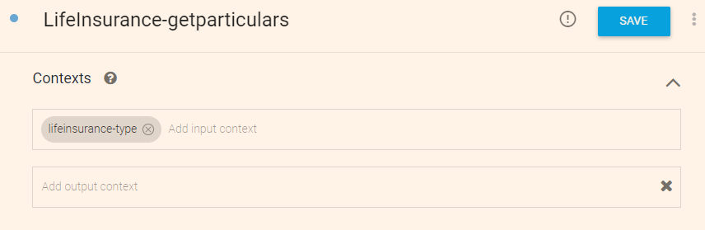

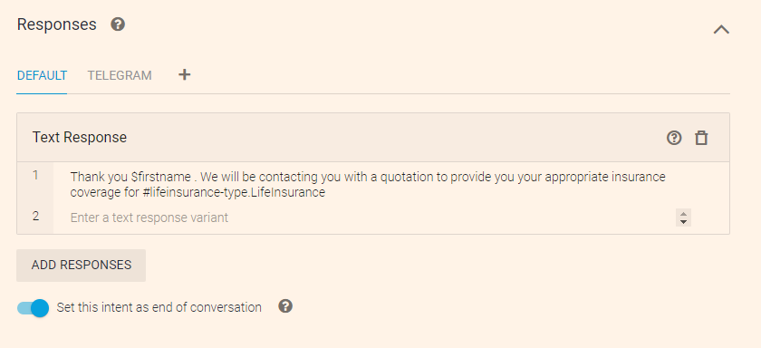

Training data sample

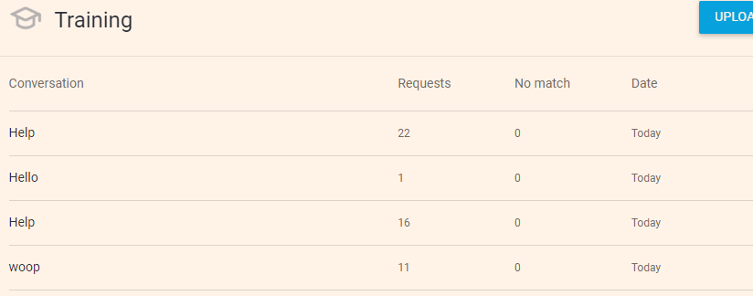

URL of the working chatbot

<https://bot.dialogflow.com/808e0e62-5356-4e26-8166-994d811fc8e4>